**Step 1: Startup Python code for your dashboard.**

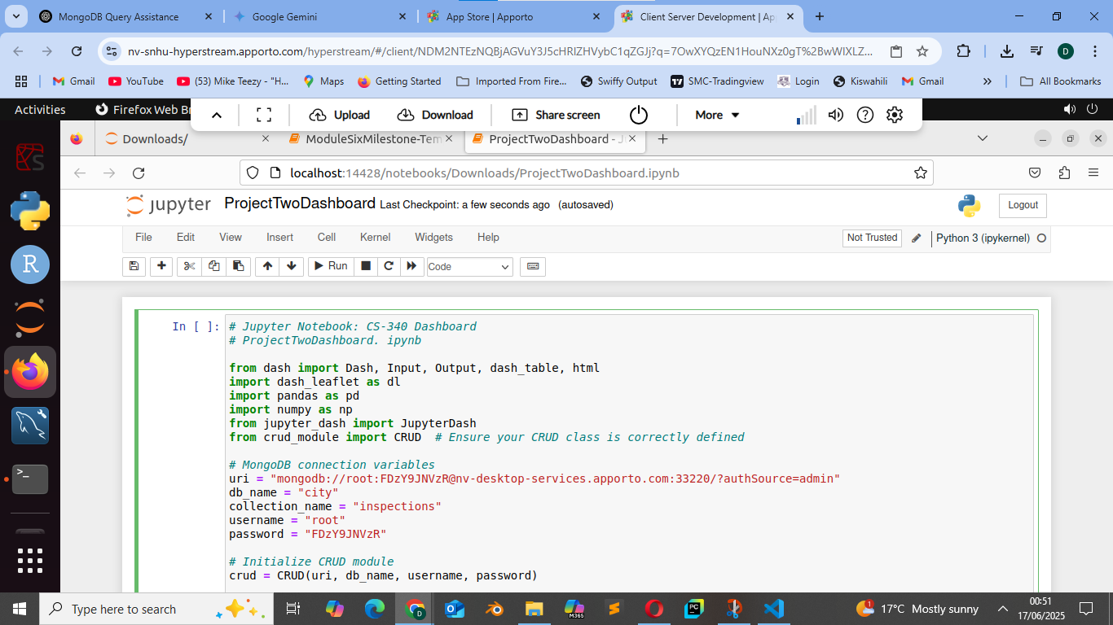

**Step 2: Dashboard Branding**

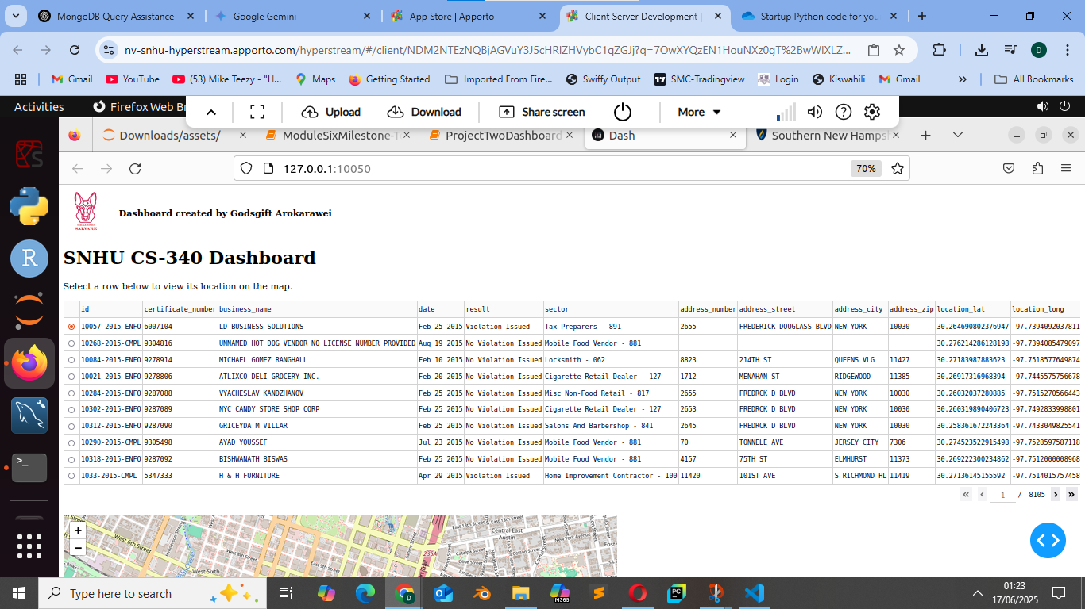

**Step 3: Filtering System**

1. Water Rescue

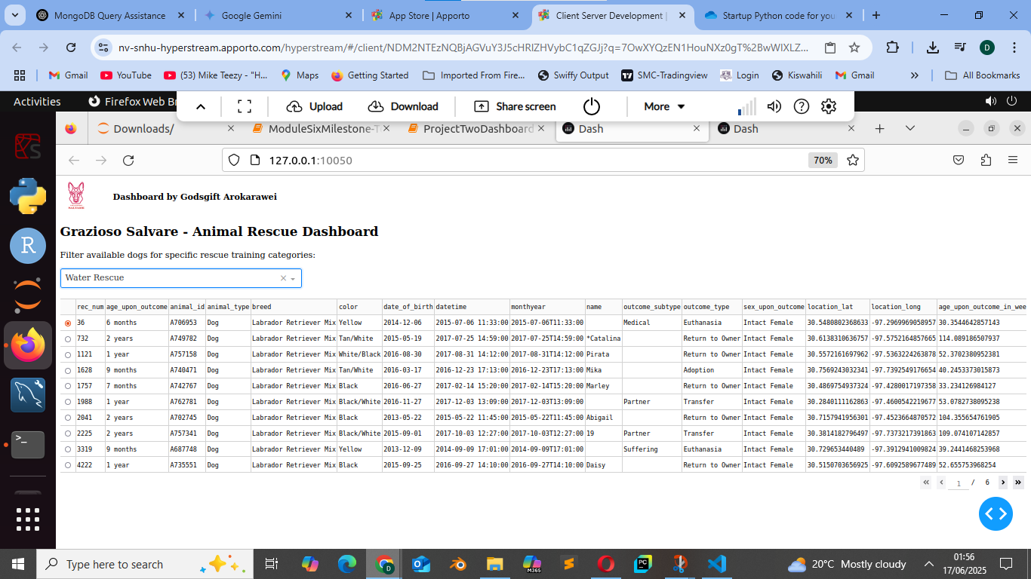

1. Mountain or wilderness Rescue

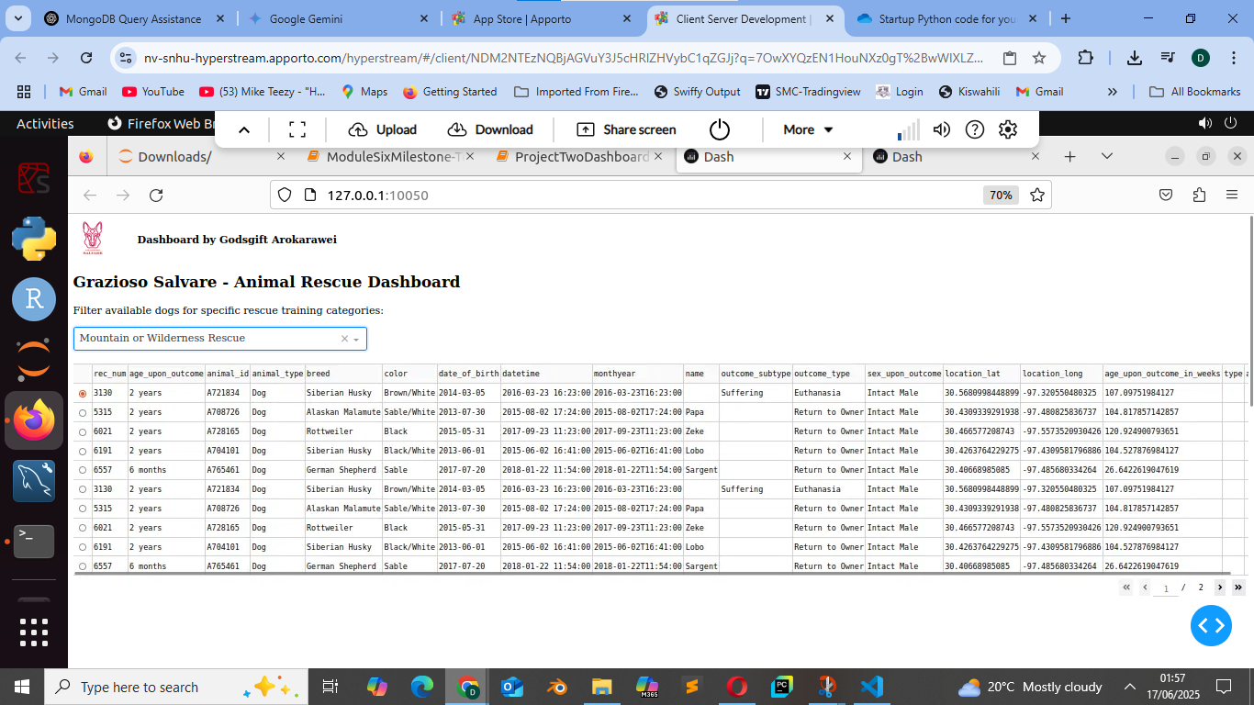

1. Disaster or Individual Tracking

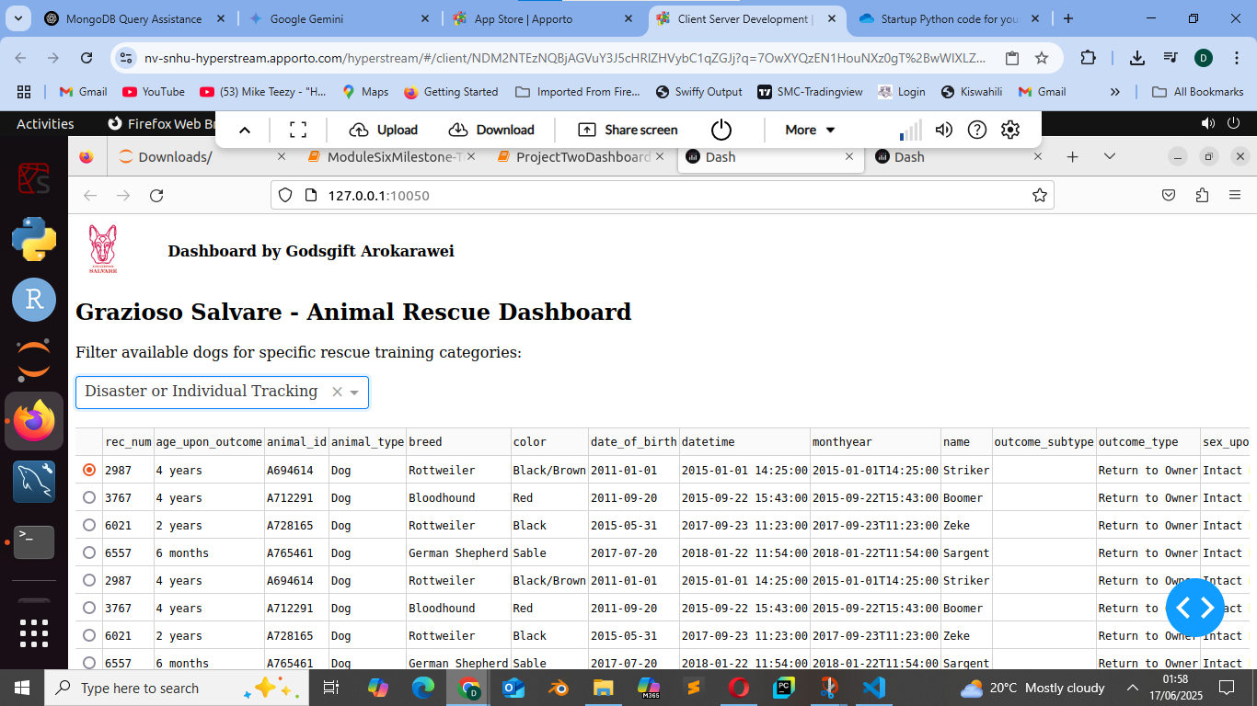

1. Reset Filters

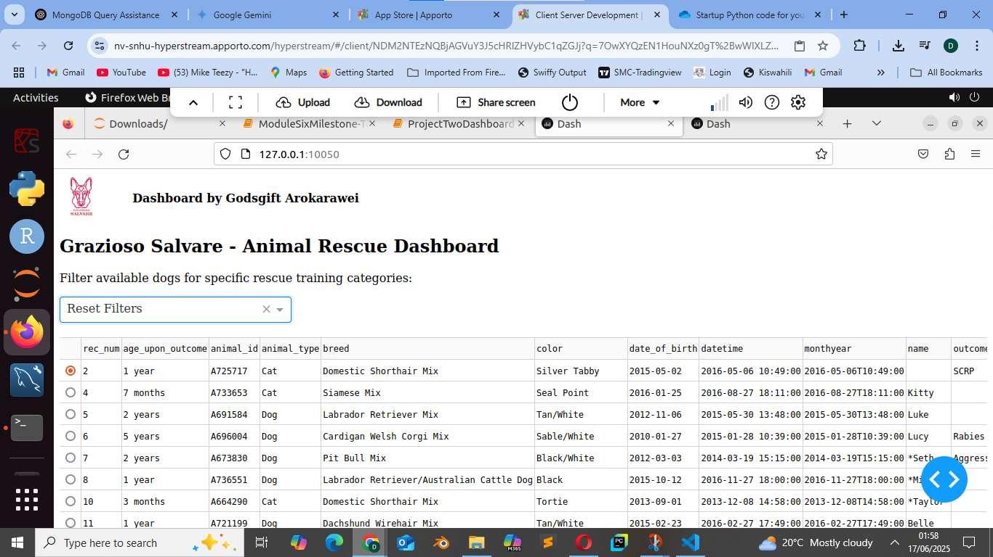

**Step 4: Dynamic Widgets**

1. **Full Dashboard (Initial State)**

* Shows:
  + SNHU logo
  + Your name
  + Rescue dropdown
  + Full data table (before filtering)
  + Both charts (pie + bar)
  + The map

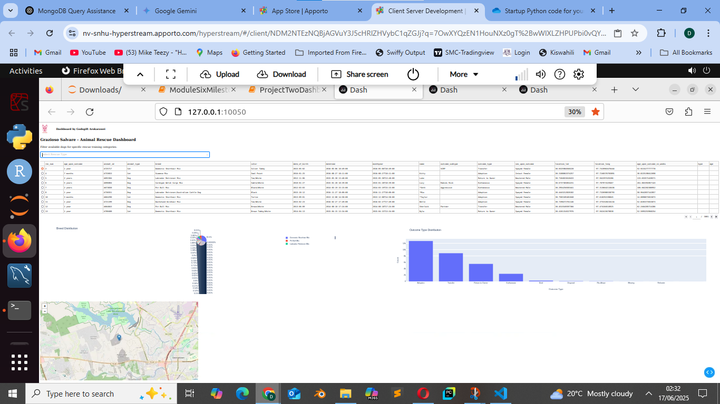

2. **After Selecting a Rescue Type (Mountain or Wilderness Rescue)**

Filtered data in the table

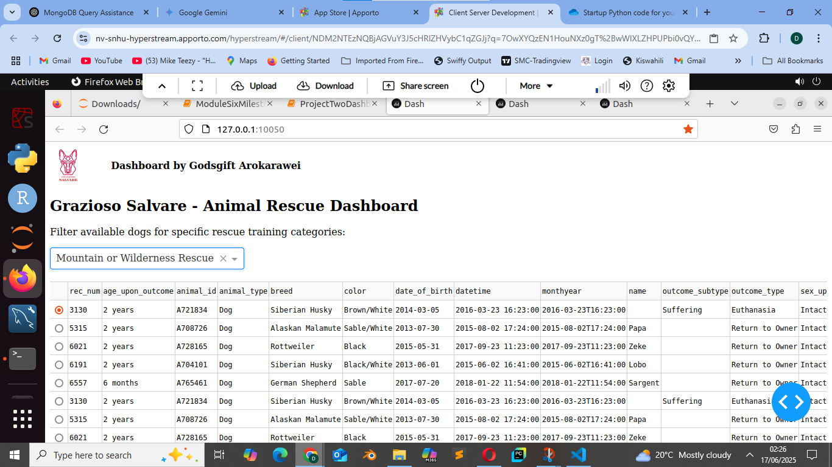

Pie Chart and Bar Chart

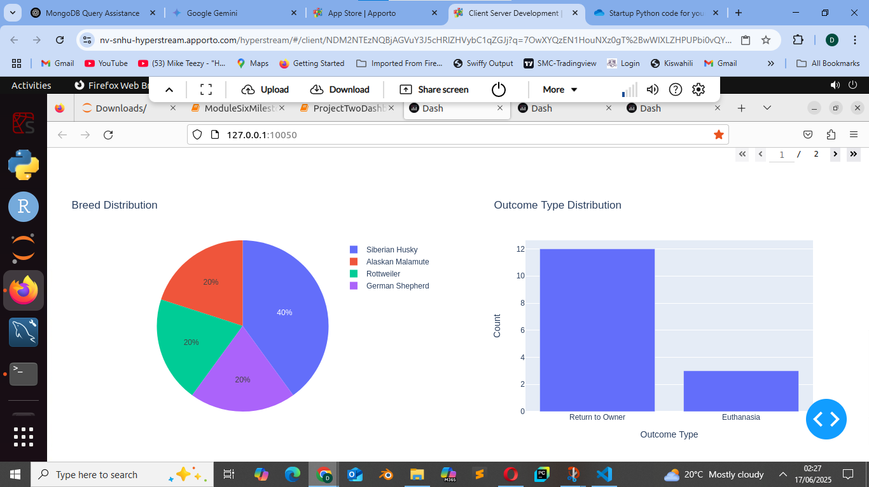

Geolocation Map

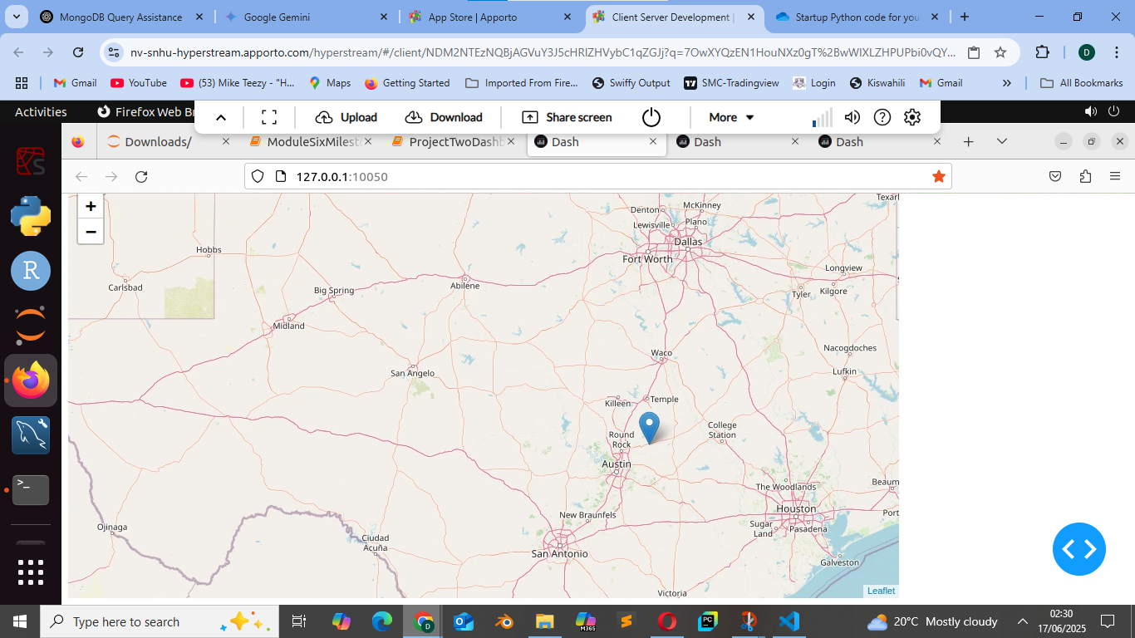

Pie Chart Close-Up

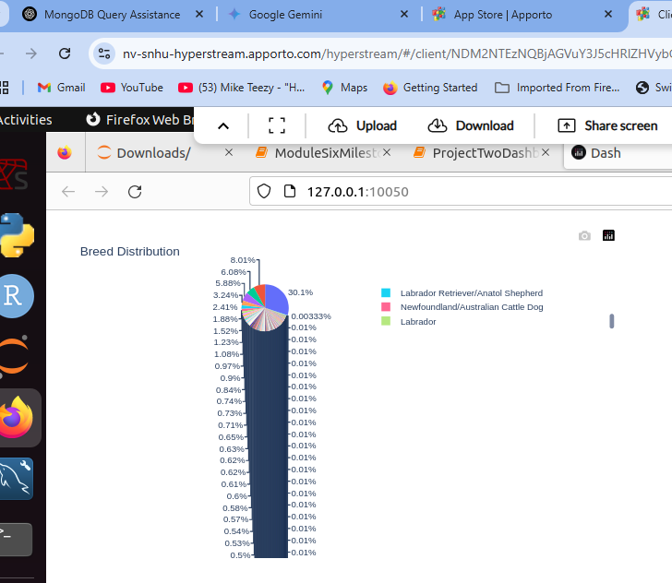

Bar Chart Close-Up

